Detailed Technical Design Document

Gogy - AI Education Platform
COS 420 - Software Engineering

Design Class Diagram
The full scale version of this diagram is available on Mermaid.

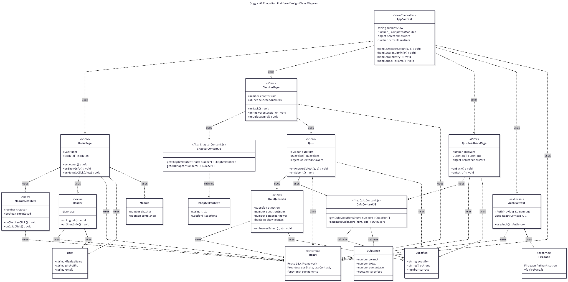

Narrative - Architecture Overview

Application Structure
Gogy is a React-based AI education platform implementing a single-page application architecture. The application follows a component-based design pattern with clear separation between view components, controller logic, helper functions, and domain objects. The main controller (AppContent) manages application state and orchestrates navigation between different views based on user interactions.

Component Architecture
The application consists of several key view components that render different parts of the user interface:

- Header: Displays user profile information and navigation controls
- HomePage: Main landing page showing available learning modules
- ModuleListItem: Individual module representation with chapter link and quiz access
- ChapterPage: Displays educational content for a specific chapter with embedded quiz
- Quiz: Interactive quiz interface for knowledge assessment
- QuizQuestion: Individual question component with multiple choice options
- QuizFeedbackPage: Results page showing score and detailed answer review

State Management
The AppContent component serves as the main view controller, maintaining critical application state including the current view (home, chapter, quiz, or feedback), completed modules tracking, selected quiz answers, and the current quiz number. This centralized state management ensures consistent data flow throughout the application and enables features like progress tracking and answer persistence.

Authentication System
User authentication is handled through Firebase Authentication, abstracted behind a custom AuthContext. The useAuth hook provides components with access to the current user object and authentication methods (login/logout). The AuthProvider wraps the entire application, making authentication state available globally through React's Context API.

Content Management
Educational content and quiz data are managed through separate helper function modules. ChapterContent.js provides functions to retrieve chapter content and enumerate available chapters. QuizContent.js manages quiz questions and score calculation logic. This separation allows for easy content updates without modifying component logic.

Design Patterns

Observer Pattern (React State)
Description: The application implements the Observer pattern through React's built-in state management. When state changes in the AppContent controller, all child components that depend on that state are automatically notified and re-rendered. This is achieved through React's component lifecycle and prop passing mechanism.

Example Implementation: When a user completes a quiz with a perfect score, the completedModules state is updated in AppContent. This triggers a re-render of HomePage, which updates the ModuleListItem components to display the completion star. All observers (child components) automatically reflect the new state without manual notification.

State Pattern (View Management)
Description: The application uses the State pattern to manage different views based on the currentView state variable. The behavior of the application changes completely based on this state - showing the home page, chapter content, quiz interface, or feedback page. Each state corresponds to a different user experience with distinct functionality.

Example Implementation: The currentView state can be 'home', 'chapter1', 'quiz1', or 'feedback'. Based on this value, AppContent renders completely different components with different behaviors. Transitions between states are triggered by user actions like clicking a chapter link or submitting a quiz.

Facade Pattern (Helper Functions)
Description: The ChapterContent and QuizContent modules act as facades, providing simple interfaces to complex content management operations. These modules hide the internal data structures and provide clean, easy-to-use functions for retrieving chapters, questions, and calculating scores.

Example Implementation: Components call getChapterContent(chapterNum) without needing to know how content is stored or structured internally. The facade handles data retrieval, formatting, and returns a consistently structured ChapterContent object. Similarly, calculateQuizScore abstracts the scoring logic behind a simple function call.

Context API Pattern (Authentication)
Description: Firebase authentication is integrated using React's Context API through AuthContext. This provides global access to authentication state and methods without prop drilling. The AuthProvider component wraps the application and makes the useAuth hook available to all child components.

Example Implementation: Any component can access user authentication data by calling const { user, logout, loading } = useAuth(). This eliminates the need to pass user props through multiple component layers and centralizes authentication logic.

External Dependencies

React (18.x)
Purpose: Core UI framework for building component-based user interface

Usage: All components use React functional components with hooks (useState, useContext)

Firebase (9.x)
Purpose: Authentication service for user login/logout functionality

Usage: Integrated through firebase.js configuration file, used by AuthContext

Facade: AuthContext.js provides a facade with useAuth hook and AuthProvider

React Router (Potential - 6.x)
Purpose: Client-side routing (if implemented beyond state-based navigation)

Usage: Currently using state-based view switching, but could be enhanced with React Router

Domain Objects and Types

User
Description: Represents an authenticated user in the system

Attribute | Type | Description
displayName | string | User's full name
photoURL | string | URL to user profile image
email | string | User email address

Module
Description: Represents a learning module with completion status

Attribute | Type | Description
chapter | number | Chapter number identifier
completed | boolean | Whether user achieved perfect score

Question
Description: Quiz question with multiple choice options

Attribute | Type | Description
question | string | Question text
options | string[] | Array of answer choices
correct | number | Index of correct answer

ChapterContent
Description: Educational content for a chapter

Attribute | Type | Description
title | string | Chapter title
sections | Section[] | Array of content sections

QuizScore
Description: Results of quiz assessment

Attribute | Type | Description
correct | number | Number of correct answers
total | number | Total number of questions
percentage | number | Score as percentage
isPerfect | boolean | Whether score is 100%

Correspondence to Domain Model
The Design Class Diagram builds upon and extends the domain model concepts:

Domain Model Entities Evolved in Design
User (Domain Model) → User (Design)
- Domain model specified: email, username, password
- Design implementation uses Firebase Authentication which provides: displayName, photoURL, email
- Evolution: Authentication is handled by Firebase rather than custom implementation, so password is not stored in the User object. The username concept is replaced by displayName for better user experience. Added photoURL for profile image support.
Content (Domain Model) → ChapterContent (Design)
- Domain model specified: chapterName, getQuizzes()
- Design implementation: title, sections: Section[]
- Evolution: Renamed chapterName to title for clarity. The getQuizzes() method is now handled by the separate QuizContent.js helper module with getQuizQuestions() function, separating content retrieval from content structure.
Quiz (Domain Model) → Quiz Component + QuizContent.js (Design)
- Domain model specified: quizID, quizName, getQuizzes(), getQuestionContents(), getFeedback()
- Design implementation splits into:
  - Quiz View Component: Handles UI rendering with props for quizNum, questions, selectedAnswers, callbacks
  - QuizContent.js: Contains getQuizQuestions() and calculateQuizScore() functions
- Evolution: Quiz identity is simplified to use chapter numbers rather than separate IDs and names. Methods are converted to standalone functions in helper modules. Feedback is handled by a dedicated QuizFeedbackPage component rather than a Quiz method.
QuestionsContent (Domain Model) → Question (Design)
- Domain model specified: questionID, correctAnswer, solutionExplanation, selectAnswer(), getQuestionContents()
- Design implementation: question: string, options: string[], correct: number
- Evolution: Simplified from methods to pure data structure. questionID is replaced by array index. solutionExplanation feature not yet implemented in current design. selectAnswer() method moved to AppContent's handleAnswerSelect() controller method. getQuestionContents() replaced by getQuizQuestions() in QuizContent.js.
Answer (Domain Model) → selectedAnswers object (Design)
- Domain model specified: userID, questionID, selectedAnswer
- Design implementation: Object mapping questionIndex to optionIndex, stored in AppContent state
- Evolution: Simplified to in-memory state objects rather than persistent entities. User association is implicit (current logged-in user). Question identification uses array indices rather than IDs.
Visuals (Domain Model) → Not Directly Implemented
- Domain model specified: visualType, url, loadDiagrams()
- Design status: This entity is not currently implemented in the design
- Future consideration: Could be added to ChapterContent as a visuals: Visual[] array if multimedia content is needed

New Design Elements Not in Domain Model
- Module: New type for tracking chapter completion status (chapter, completed)
- QuizScore: New type for structured quiz results (correct, total, percentage, isPerfect)
- View Components: All React UI components (Header, HomePage, ModuleListItem, ChapterPage, etc.) are presentation layer additions
- AppContent Controller: Main state management and navigation controller not represented in domain model
- AuthContext: Authentication abstraction layer using React Context API
- Helper Function Modules: ChapterContent.js and QuizContent.js provide separation of business logic

